***ISSYP*** Dirac Belt Trick 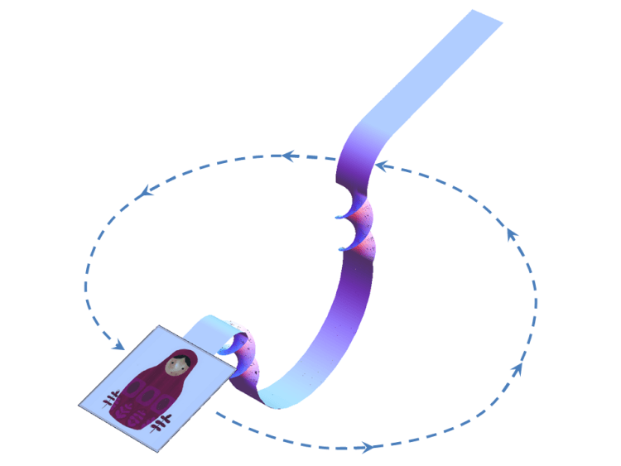

Twist the card and ribbon around twice or 720o.

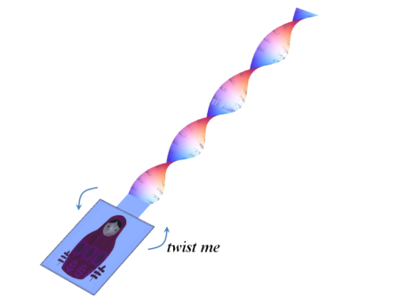

Slacken the ribbon with the twists still in it and, holding the card in the selfsame, constant *orientation*, pass it under the ribbon by taking it along a path like the broken line path as shown in the following sequence.

|  |  |
| --- | --- |
| [Undoing Double Twist 1](http://i2.wp.com/www.wetsavannaanimals.net/wordpress/wp-content/uploads/2014/01/Undoing-Double-Twist-1.png) | [Undoing Double Twist 2](http://i0.wp.com/www.wetsavannaanimals.net/wordpress/wp-content/uploads/2014/01/Undoing-Double-Twist-2.png) |
| [Undoing Double Twist 3](http://i1.wp.com/www.wetsavannaanimals.net/wordpress/wp-content/uploads/2014/01/Undoing-Double-Twist-3.png) | [Undoing Double Twist 4](http://i1.wp.com/www.wetsavannaanimals.net/wordpress/wp-content/uploads/2014/01/Undoing-Double-Twist-4.png) |
| [Undoing Double Twist 5](http://i0.wp.com/www.wetsavannaanimals.net/wordpress/wp-content/uploads/2014/01/Undoing-Double-Twist-5.png) | [Undoing Double Twist 6](http://i2.wp.com/www.wetsavannaanimals.net/wordpress/wp-content/uploads/2014/01/Undoing-Double-Twist-6.png) |

Repeat this procedure with only a single 360o twist and compare.